**Nitride film 1 MT-455**

Ragula Bhoopal

20ETMM11

Group-2

**Aim:** To determine crystallite size and lattice strain for the given data.

**Procedure:**

Given the instrumental broadening value,

Gaussian equation 

 where, $η=S\text{train in the material}$ $$\text{L= Crystallite Size} \\ \text{k=0.94}$$

$λ=0.154nm$

Comparing the above equation with  Where, 

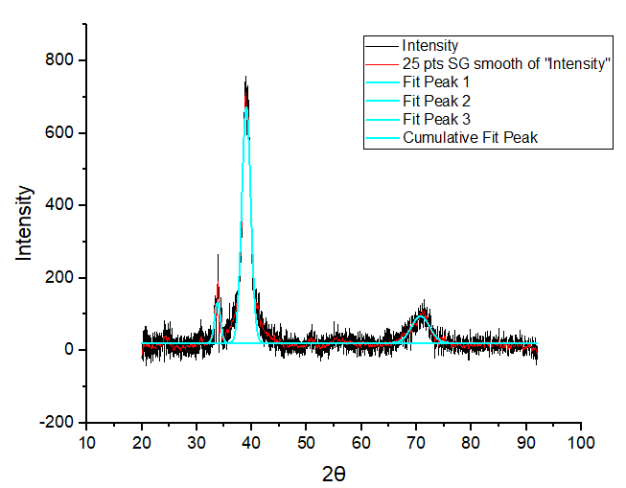

|  |  |  |  |  |  |  |  |
| --- | --- | --- | --- | --- | --- | --- | --- |
| **2θ** | **θ(rad)** | **Bo(fwhm)** | **Bo(rad)** | **Bo2** | **Bi(deg)** | **Bi(rad)** | **Bi2** |
| 33.76656 | 0.294669 | 1.27552 | 0.022262 | 0.000496 | 0.045 | 0.000785 | 6.17E-07 |
| 39.00728 | 0.340403 | 1.928 | 0.03365 | 0.001132 | 0.045 | 0.000785 | 6.17E-07 |
| 70.73872 | 0.617312 | 3.89281 | 0.067942 | 0.004616 | 0.045 | 0.000785 | 6.17E-07 |

|  |  |  |  |
| --- | --- | --- | --- |
| **Br2=Bo2-Bi2** | **Br** | **Brcosθ** | **sinθ** |
| 0.000495 | 0.022248 | 0.021289 | 0.290423 |
| 0.001132 | 0.033641 | 0.03171 | 0.333867 |
| 0.004616 | 0.067938 | 0.055399 | 0.578845 |

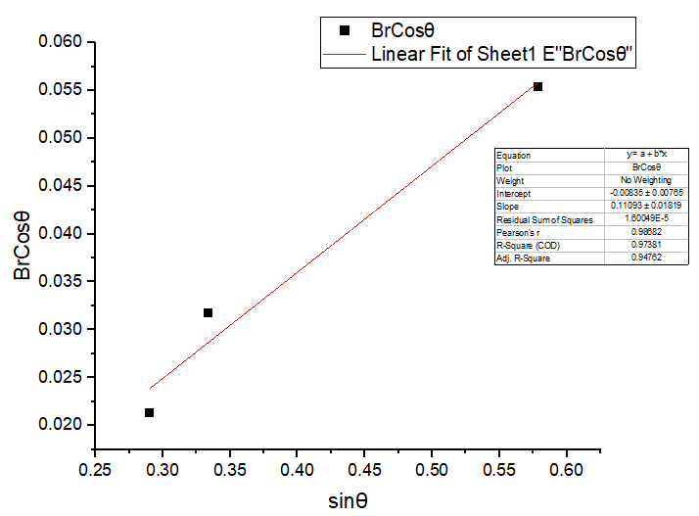

|  |  |
| --- | --- |
| Equation | y = a + b*x |
| Plot | BrCosθ |
| Weight | No Weighting |
| Intercept | -0.00835 ± 0.00765 |
| Slope | 0.11092 ± 0.01819 |
| Residual Sum of Squares | 1.6005E-5 |
| Pearson's r | 0.98682 |
| R-Square (COD) | 0.97381 |
| Adj. R-Square | 0.94762 |

$$b=Slope=η \\ a=Intercept=\frac{kλ}{L} \\ Therefore, η=0.11092 \\ \frac{kλ}{L}=0.00835 \\ L=\frac{kλ}{0.00835} \\ L=\frac{0.94×0.154}{0.00835} \\ L=17.3365\text{ nm}$$

**Result**

$$η=S\text{train in the material=}0.11092 \\ \text{L= Crystallite Size}=17.3365 \text{nm}$$